Create Template
- Create base template in the app
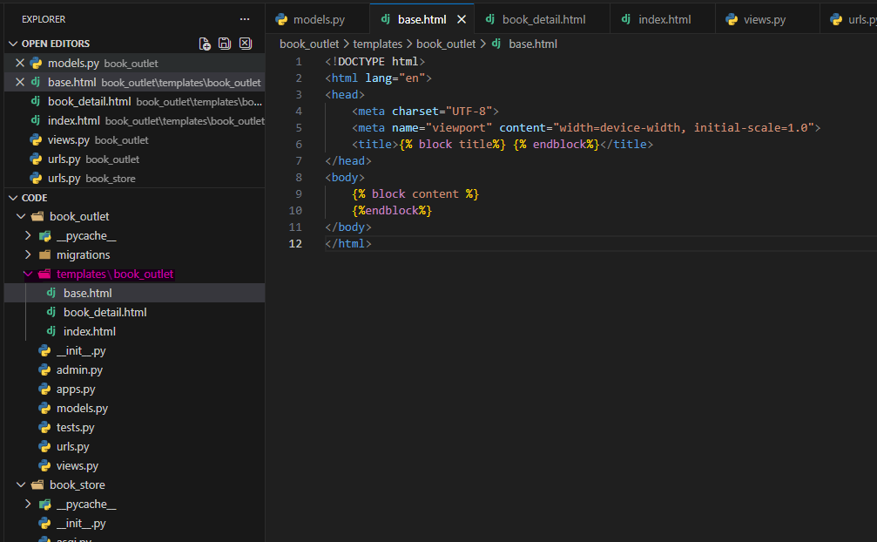

>> create templates >> base.html, index.html

<!DOCTYPE html>
<html lang="en">
<head>
<meta charset="UTF-8">
<meta name="viewport" content="width=device-width, initial-scale=1.0">
<title>{% block title%} {% endblock%}</title>
</head>
<body>
{% block content %}
{%endblock%}
</body>
</html>

>>> Create index.html

{% extends "book_outlet/base.html" %}

{% block title%}
All Books
{% endblock %}

{% block content%}
<ul>
<li>Book 1....</li>
</ul>
{%endblock%}

>> Create Views.py

from django.shortcuts import render

# Create your views here.

def index(request):
return render(request, "book_outlet/index.html")

>> Create urls.py (in the app)

from django.urls import path
from . import views

urlpatterns = [
path("",views.index)
]

>> Import template to the project urls.py (in the project)

from django.contrib import admin
from django.urls import path, include

urlpatterns = [
path('admin/', admin.site.urls),
path("",include("book_outlet.urls"))
]

